DATE

NAME
ADDRESS LINE 1
ADDRESS LINE 2
CITY, STATE ZIP

Dear _____________,

Thank you for agreeing to lend $_____ at the terms specified on page three of this letter to the Boston Community Loan Fund, Inc. (the Loan Fund). The purpose of this letter is to describe to you the Loan Fund’s understanding of the terms and conditions of your loan, as well as to disclose to you certain policies, procedures, and other matters regarding the Loan Fund and the Loan Fund’s use of the proceeds of your loan.

The Loan Fund is a tax-exempt, nonprofit Massachusetts corporation organized for the purpose of raising money to finance community-based development projects. These projects increase or preserve the supply of low-income housing or provide jobs or services for low-income or disadvantaged people or communities. The Loan Fund is also a member of the Opportunity Finance Network (OFN). OFN, with over 160 active members, was formed to provide local community loan funds, such as the Loan Fund, with technical assistance and other advice; OFN does not, however, guarantee the performance of any of its members, nor does it insure or guarantee any loans made for or by its members.

The Loan Fund accepts loans and grants from individuals, private and public foundations and others. The Loan Fund then pools the proceeds of those loans and grants with other income of the Loan Fund to make loans, at below market rates, for the benefit of community development projects.

The Loan Fund asks that you give careful attention to the general terms, conditions, and policies described in this letter, which apply generally to all loans and grants made by the Loan Fund, including your loan, as well as any special conditions, if any, that relate only to your loan. By signing the enclosed two copies of this letter on page three and returning them to the Loan Fund, you indicate your understanding and acceptance of such terms, conditions and policies.

General Terms, Conditions and Policies

1. To the extent that the proceeds of loans or grants made to the Loan Fund are not immediately used for financing community development projects, the Loan Fund reserves the right to deposit such proceeds into one or more accounts or any other investment that may or may not bear interest. These proceeds may be commingled with the proceeds from other loans, grants, and donations to the Loan Fund and other income to the Loan Fund.

The Loan Fund agrees to use the principal amount of the loans made to the Loan Fund only for the purpose of providing financing for community development projects. The Loan Fund reserves the right, however, to use any interest or other income earned with respect to the principal for any of the Loan Fund’s corporate purposes and needs, such as paying interest due on loans made to the Loan Fund, paying the Loan Fund’s administrative and operating expenses, making loans for community development projects, contributing to the permanent capital fund established for the Loan Fund, and supporting affiliated organizations that are pursuing nonprofit purposes that are similar to or that complement the goals of the Loan Fund.

3. Your loan to the Loan Fund is at a below-market rate; the Loan Fund understands that you have agreed to charge a low interest rate in order to assist the Loan Fund’s pursuit of its goals of supporting community development for lower-income households and other disadvantaged persons.

4. The interest rate charged by the Loan Fund on the loans it makes to finance community development projects bears no relationship to the interest payable to you under your loan. The Loan Fund reserves the right to determine the interest rate it charges based on a given project’s need for funds and ability to pay, the Loan Fund’s overall cost of funds, and similar factors.

5. Although the Loan Fund intends to use the proceeds of your loan to provide financing for community development projects, you will have no legal or other right to look to any such project for repayment; your only recourse for repayment of your loan will be against the Loan Fund.

6. Your loan is unsecured. This means that the Loan Fund is not granting you a security interest in, a mortgage on, or pledge of any property or assets or collateral as security for the loan. Your only security is the legally binding promise of the Loan Fund to repay you subject to the terms of this agreement; the Loan Fund will evidence that promise by delivering to you a promissory note.

7. Depending on your personal circumstances, your below market rate loan to the Loan Fund may give rise to imputed income consequences under federal and state income tax laws. You should consult your own tax advisor in that regard. If your loan earns interest, you will receive a 1099-INT form by January 31 of each year. All lenders earning interest must file a W-9 form with this letter.

8. The Loan Fund encourages lenders to allow the Loan Fund to use their names publicly, however, the Loan Fund will keep your identity strictly confidential unless you expressly authorize us in writing to disclose your identity by signing the attached disclosure waiver.

9. Prior to signing this letter, you should review the Loan Fund’s most recent audited annual financial statements and its most recent quarterly financial statements. In connection with making your loan you are encouraged to review this material and to contact the President for any additional information about this material or the Loan Fund’s condition and practices that you wish. By signing the copy of this letter you acknowledge that the Loan Fund has provided you with this opportunity to obtain additional information. The Loan Fund will provide you, at least once a year, with a written report of the Loan Fund’s lending activities and financial condition.

If you wish to lend money to the Loan Fund on the terms and conditions described above, please acknowledge your understanding of, and agreement to, the terms of this letter by countersigning and returning the two enclosed copies to me, together with your check in the amount of $_______ payable to Boston Community Loan Fund. We will then have both copies signed on behalf of the Loan Fund and return one fully executed counterpart to you, together with the Loan Fund’s promissory note in the amount of your loan.

Thank you for your interest and support of the Loan Fund and its goals.

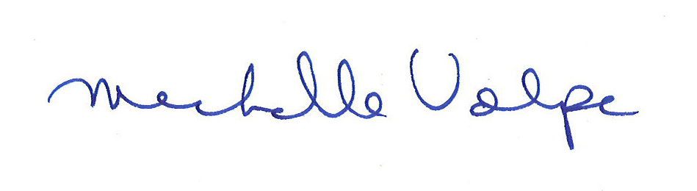
Sincerely yours,

Michelle Volpe
President

Amount of loan: $_____

Interest rate: ___%

For loans maturing in less than 3 years, the maximum interest rate is 1%; for loans maturing in 3-5 years, the maximum interest rate is 2%; for loans maturing in greater than 5 years or greater than $200,000, interest rates can be negotiated.

Payment schedule: Annually
Interest Payment Date: June 30
Repayment date: June 30, 20___

The Loan Fund repays loans on June 30 of each year. Loans must be made for a minimum of one year. The Loan Fund will consider exceptions in extraordinary cases.

The undersigned hereby understands and agrees to the terms of the foregoing letter this _______ day of ____________, 20_____.

_______________________________________

By its signature below, the Loan Fund acknowledges receipt of your check in the amount of $_______, which the Loan Fund shall apply in accordance with the terms of the
foregoing letter.

Boston Community Loan Fund, Inc.

By ________________________

Its ________________________

Date _________________________

WAIVER OF CONFIDENTIALITY

The endorsement of the work of the Boston Community Loan Fund by lenders is helpful in raising new loans and increasing the resources of the Boston Community Loan Fund.

______ I hereby authorize the Boston Community Loan Fund to publicize my/our name as a lender to the Boston Community Loan Fund.

Please print your name as you want it to appear in publication:

_____________________________________________________

______ I hereby request that my name be kept confidential.

Signed ____________________________ Date ___________________________

